Knight Awarded Teaching Award
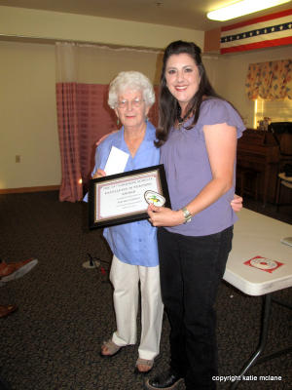
Mesilla Valley Audubon Society announced that the 14th Annual Lorraine Schulte Excellence in Teaching Award has been awarded to Rachel Knight, of Picacho Middle School. This $250 award recognizes a K-12 teacher who encourages students to appreciate and care for our environment. Knight teaches five sections of seventh grade science and one class of agriculture explorations for seventh and eighth grade students, teaching approximately 220 students each day.
Knight has worked very hard to implement environmental science, agriculture, and conservation in everyday’s curriculum. Her students work to keep the school campus clean, act as stewards of the school campus ecosystems, run the school recycling program, maintain the Adopt-A-Spot area close to campus, and participate in various Keep Las Cruces Beautiful programs and activities. She also serves on the school’s leadership team and runs the school’s “Green Team”.
Congratulations to Knight for winning this year’s teacher award.

6/02/2011 Las Cruces Sun-News

